Sheri Spinning Wheels for sale

Sheri Has been spinning yarn since about 1985. She has also been collecting spinning wheels since that time.
Now, here in 2024, she would like to begin selling some of her spinning wheels.
Every one of the wheels shown below IS operational.
Her suggested prices are listed below, but please feel free to make an offer by emailing us at:
spaco@baldwin-telecom.net
Please include the title above the picture of the wheel that interests you in your message.
Thank you,
Sheri and Pete

Antique Spinning Wheel from Miesville MN $350
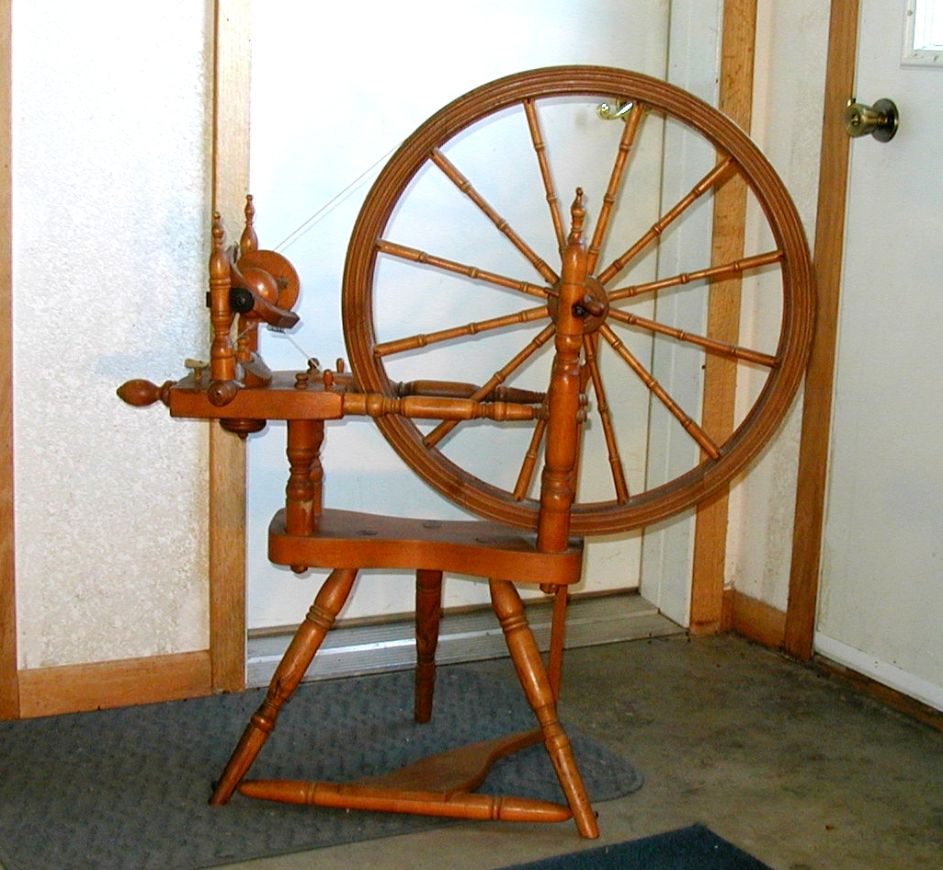
23 3/4 inch diameter wheel.
After meeting friends for lunch in Miesville in about the year 2000, we browsed the local antique store, where we found this wheel. It works well after some minor repairs on our part.

Antique Spinning Wheel number 10 $350
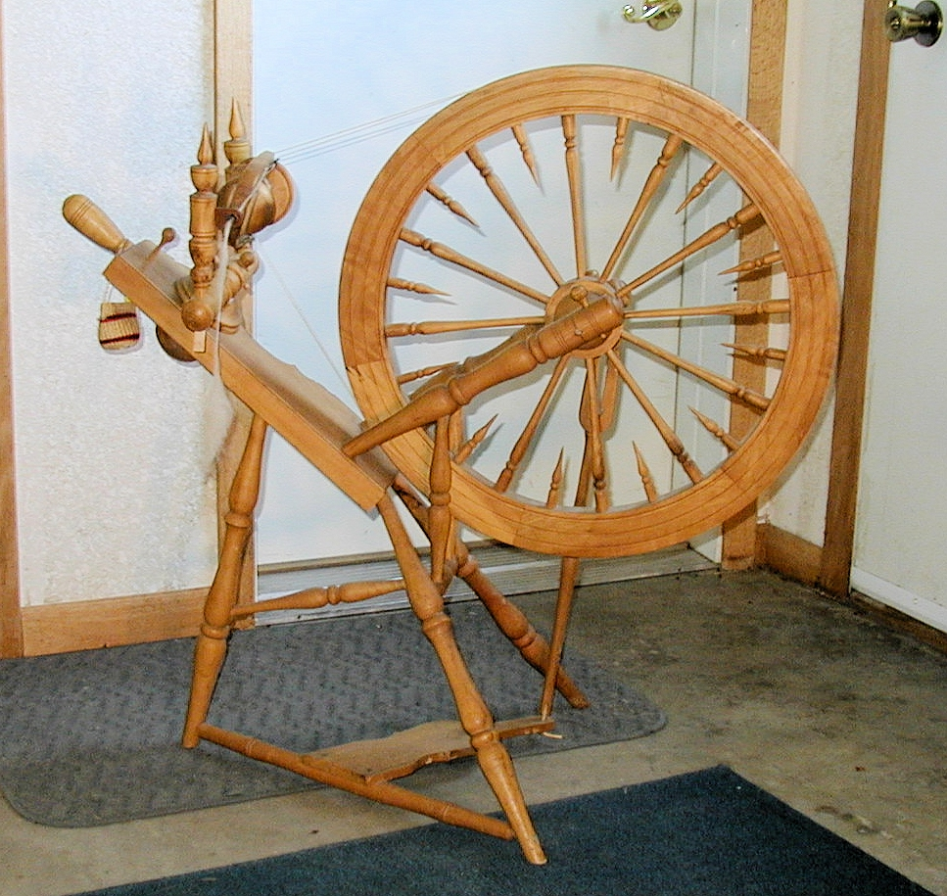
Very fancy 22 inch diameter wheel. Has a thoughtful flyer repair.

German Wheel from Decorah, Iowa $350
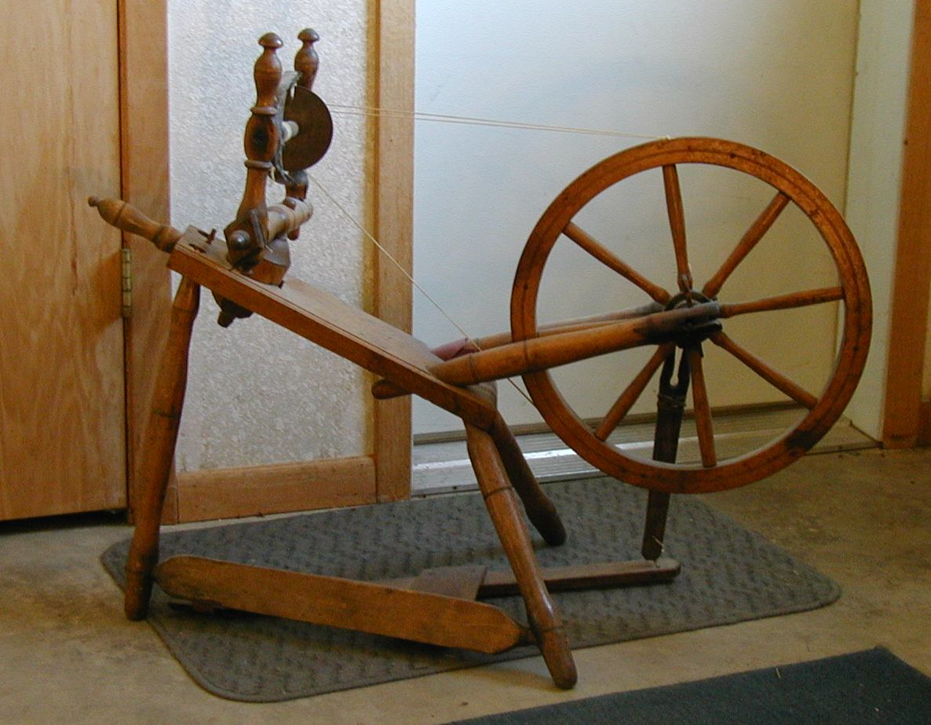
17 inch diameter wheel.
This wheel was brought from Germany in the late 1800's. It's owner traded it for a blanket at the General store in town.
Sheri's first spinning wheel. Back in about 1990, when she went to school in Decorah to formally learn to spin, the instructor, Kate Martenson, told the group about a woman in town who had removed an old wheel from her home's decor, dissassembled it and actually put it in a basket, offering to GIVE it to Kate, since she was known as THE spinning lady in town.
We asked if we could contact the lady. Okay, We did and she gave it to us. It truly was a "basket case"!
Kate used it as part of the group's training; in how to assemble and "tune up" a spinning wheel. It only needed a little care and a couple of minor parts, which Sheri's husband made.

German Wheel with Provenance $400
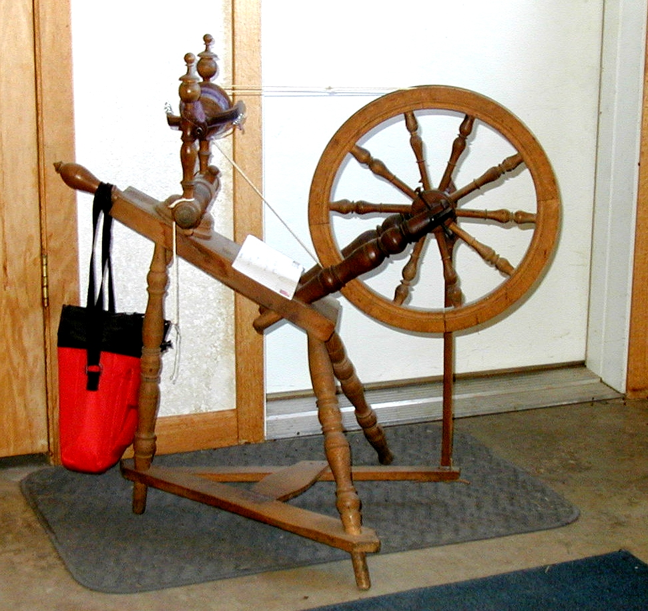
15 3/8 inch diameter wheel.
This one came over on the ship that his mother came to America on.
I was demonstrating spinning at the Rogers Threshing Show around 1995, when a man approached me with a wheel for sale. I suggested that he get an antique shop appraisal. He went away and when he returned, he said he wanted me to buy it for $200.00, which I did.
He was 80 when he sold it to me.
It comes with the letter that the man wrote for me about the wheel.
Also comes with 3 bobbins.

Rescue for Sheri by Nick $350

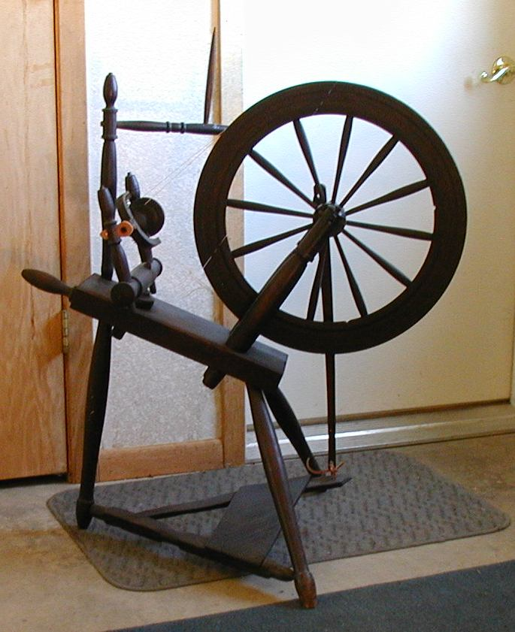
19 1/2 inch diameter wheel.
This one has a black finish that seems to be from use. VERY old.
-With Distaff

Rick Reeves Wheel $550
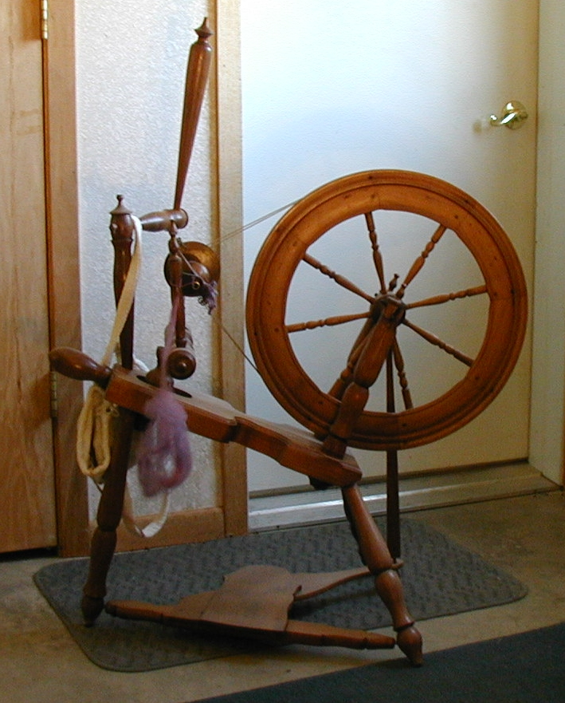
18 1/2 inch diameter wheel.
Rick Reeves was an upscale USA wheel maker for many years.
In later years, he sold out to Schacht.
But this is one of the original Rick Reeves wheels. He died on February 21, 2017, so it's a collector's wheel.
There are only a few left.
It has a flyer repair that works well.
-With Distaff

Salesman Sample $400
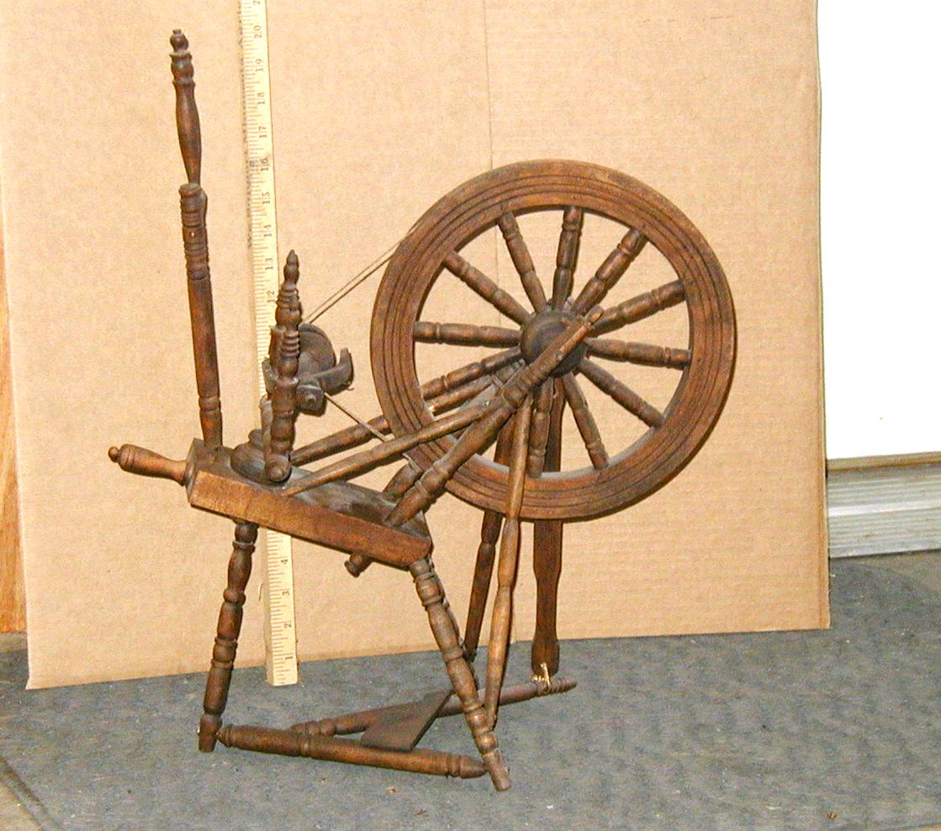
10 1/2 inch diameter wheel.
We found this one in Redwing, Mn, a couple of blocks from the old Red Wing Pottery Mall.
It's only about 16 inches tall to the top of the wheel. But very well constructed and in good working condition. We were told that salesmen of the day often carried such a tiny model with them.
-With distaff.
-------------------------------------------------------------------------

